**Snake Game Using Python**

**Abstract:**

Snake game is a popular classic arcade game that involves controlling a snake to eat food while avoiding obstacles and its own body. In this project, we aim to develop a Snake game using Python programming language. The game will utilize Python’s built-in modules such as Pygame, which is a popular module used for game development. The project will involve designing the game board, the snake, the food, and the game mechanics. The user will be able to control the snake’s movement using arrow keys, and the game will end when the snake collides with the wall or its own body. The project will also involve keeping track of the player’s score and displaying it on the screen. Overall, this project will be a fun and challenging way to practice Python programming skills while creating a classic game.

**Introduction:**

Snake game is a classic video game that has been popular for decades. The game involves controlling a snake that moves around a screen and eats objects labeled as "food." The snake grows longer as it eats the food, and the game ends if the snake collides with the walls or with itself.Pygame is a Python module that provides functionalities for game development. It allows developers to easily create games with graphics, sound, and user input. The Pygame module can be used to implement various games, including the classic snake game.The snake game implemented using Pygame in Python involves controlling a snake that moves around the screen and eats bait to grow. The game also includes a scoring system to keep track of the player's progress. The player must avoid colliding with the walls or the snake's body while attempting to grow the snake as long as possible.The code is a program that utilizes the Pygame module to create a simple snake game. The game features a snake that constantly moves on the screen and the objective is for the player to prevent the snake from hitting walls or colliding with itself. The player can control the snake's movement using the arrow keys: right, left, down, and up. The snake initially starts moving in the right direction by default.

Unlike traditional snake games where there are objects labeled as "food" on the screen for the snake to eat, this particular game does not have any visible food items. Instead, every time the snake collides with an invisible bait, it disappears, and the snake's body grows. The game keeps track of the player's score, which increases with each successful collision of the snake with the bait.The code employs different functions to execute the various tasks involved in the game, making the code modular and easy to manage. Overall, this code offers a simple yet entertaining example of how the Pygame module can be used to create a game with basic features such as movement, collision detection, and score tracking.

Overall, the snake game implemented using Pygame in Python is a fun and simple game that showcases the capabilities of the Pygame module for game development.

**Methodologies used:**

The methodology used in this code is to implement a game using the Pygame module, which provides tools and functionality for creating games and multimedia applications in Python.

The game involves a snake that moves continuously on the screen, and the player's goal is to prevent the snake from colliding with walls or with itself. The snake can be controlled using the arrow keys (right, left, down, and up).The snake starts moving in the right direction by default, and there are no objects labeled "food" on the screen. Each time the snake collides with the bait (which is not visible), the bait disappears, and the snake's body grows, and the player's score increases.The methodology used to achieve this involves defining several functions that perform specific tasks, such as initializing the game, drawing the snake and bait on the screen, handling user input, updating the snake's position and size, and checking for collisions.The game loop is implemented using a while loop that runs continuously until the player either loses the game or exits the program. During each iteration of the loop, the functions are called in a specific order to update the game state and redraw the screen.

Overall, the methodology used in this code is to break down the game logic into smaller, manageable pieces, and use functions and loops to control the flow of the game and respond to user input. The Pygame module provides the necessary tools and functionality to create an engaging and interactive game.

**1.Import the Pygame module:** The Pygame module is used for creating games in Python. The first step is to import the Pygame module using the "import" statement.

Initialize Pygame: After importing Pygame, the next step is to initialize Pygame using the "pygame.init()" function. This function initializes all the required Pygame modules.

Pygame allows developers to create games and interactive applications in a simple and easy-to-understand manner. It provides a range of features, including:

* Drawing: Pygame allows you to draw shapes, images, and text on the screen. You can also create animations by changing the position, size, and orientation of these objects over time.
* Input handling: Pygame provides a way to handle user input from devices such as keyboards, mice, and gamepads. You can detect when a key is pressed or released, or when a mouse button is clicked or moved.
* Sound and music: Pygame can play sounds and music files in various formats. You can control the volume, pitch, and other properties of the audio.
* Networking: Pygame includes a simple networking module that allows you to create networked games and applications.Cross-platform support: Pygame can run on different operating systems, including Windows, Mac OS X, and Linux.

Set up the game window: The game window is created using the "pygame.display.set_mode()" function. This function sets the width and height of the game window.

**2.Define the game objects:** The game objects are defined using classes. In this case, the game objects include the snake, the bait, and the score.

there are two main game objects: the snake and the bait.

The snake is represented as a series of rectangular blocks, with the first block being the head of the snake. The size and position of the blocks are updated every frame of the game loop to create the illusion of movement. The snake's movement is controlled by the player using the arrow keys, and the snake can change direction but cannot move backward.The bait is a small, invisible object that is randomly placed on the screen at the start of the game and each time the snake eats it. When the snake collides with the bait, it grows by adding a new block to the end of its body, and the player's score is incremented. After being eaten, the bait disappears and is repositioned randomly on the screen.In addition to the snake and bait, there are also walls on the screen that the snake must avoid colliding with. These are represented as solid rectangles and are positioned at the edges of the screen.

**3.Implement the game loop:** The game loop is the core of any game. It is responsible for updating the game state, rendering the game, and handling user input. In this code, the game loop is implemented using a while loop. The game loop repeatedly updates the game state, renders the game, and handles user input until the game is over.

The game loop is a crucial part of any game, as it controls the flow of the game and ensures that it runs smoothly and responsively. In the code snippet provided, the game loop is implemented using a while loop that runs continuously until the player either loses the game or exits the program. Here's a step-by-step explanation of how the game loop is implemented in this code:The game is initialized using the pygame.init() function to initialize all the Pygame modules required for the game.The screen is set up using the pygame.display.set_mode() function, which creates a new Pygame window with the specified dimensions.The game clock is created using the pygame.time.Clock() function, which is used to regulate the frame rate of the game.The initial state of the game is set up, including the snake's starting position, size, and direction, as well as the score and other game variables.

The while loop is started, which runs continuously until the player loses the game or exits the program.The game clock is ticked using the clock.tick() function, which regulates the frame rate of the game to ensure that it runs smoothly and consistently across different systems.

The user input is captured and processed using the pygame.event.get() function, which retrieves all the events from the Pygame event queue, such as keyboard input or mouse clicks.The snake's position, size, and direction are updated based on the user input and the game rules. For example, if the player presses the right arrow key, the snake's direction is updated to move to the right in the next frame.The collision detection function is called to check if the snake has collided with the wall or with itself, and if so, the game is over.

The collision detection function is also called to check if the snake has collided with the bait, and if so, the bait is reset to a new position, and the snake's size is increased, and the player's score is updated.The graphics are updated and redrawn on the screen using the pygame.draw functions to create smooth and seamless animation.The player's score and other game information are displayed on the screen using the pygame.font functions to create text objects.The updated graphics are displayed on the screen using the pygame.display.flip() function, which updates the Pygame window with the latest changes.If the player loses the game or exits the program, the while loop is exited, and the Pygame modules are uninitialized using the pygame.quit() function.

**4.Implement collision detection:** Collision detection is used to detect when the snake collides with the walls or with itself. This is implemented using the "pygame.sprite.spritecollide()" function.

To detect collisions with the wall, the check_collision_wall function takes in the snake's head position and the dimensions of the Pygame screen as arguments.The function checks if the snake's head has gone beyond the boundaries of the screen. If it has, the function returns True, indicating that the snake has collided with the wall and the game is over.

To detect collisions with the snake's body, the check_collision_body function takes in the snake's head position and its body segments as arguments.

The function checks if the snake's head has collided with any of its body segments by iterating over each segment and checking if its position matches the head position. If there is a match, the function returns True, indicating that the snake has collided with itself, and the game is over.Both collision detection functions are called in the main game loop to check for collisions every frame.If a collision is detected, the game over function is called, and the game loop is exited.

**5.Handle user input:** User input is handled using the Pygame event system. The code listens for key presses and updates the direction of the snake accordingly.

Handling user input is a crucial aspect of any game that involves player interaction. In the code snippet provided, user input is handled using Pygame's built-in event handling system. Here's an explanation of how user input is handled in this code:

In the main game loop, we use a for loop to iterate over all the events that Pygame detects.We then use an if statement to check if the event is a QUIT event, which is triggered when the user clicks the close button on the window. If it is a QUIT event, we call the pygame.quit() function to close the Pygame window and exit the game.

We also check for key events using another if statement. We use the pygame.K_LEFT, pygame.K_RIGHT, pygame.K_UP, and pygame.K_DOWN constants to check if the user has pressed one of the arrow keys.If the user has pressed one of the arrow keys, we update the direction of the snake accordingly by changing the dx and dy variables. For example, if the user presses the left arrow key, we set dx to -SNAKE_BLOCK and dy to 0, which will move the snake one block to the left.We also use another if statement to check if the user has pressed the SPACE key to restart the game. If they have, we call the game_loop() function to restart the game.

**6.Update the game state:** The game state is updated in the game loop. This includes moving the snake, checking for collisions, and updating the score.

In the main game loop, we move the snake by updating the coordinates of the snake's head based on the current direction of the snake. We then append the new head coordinates to the snake_coords list and remove the tail of the snake by slicing the list. This creates the illusion of the snake moving.We then check for collisions using two functions:check_collision_wall()andcheck_collision_body().Thecheck_collision_wall() function checks if the snake has collided with the walls of the game screen, while the check_collision_body() function checks if the snake has collided with its own body. If a collision is detected, we call the game_over() function to end the game.

If the snake has not collided with anything, we update the score by incrementing the score variable. We also check if the snake has collided with the bait by comparing the coordinates of the snake's head with the coordinates of the bait. If a collision is detected, we remove the bait, increment the score variable, and add a new bait to the game screen.Finally, we update the game screen by drawing the snake, the bait, and the score using Pygame's drawing functions.

**7.Render the game:** Rendering is the process of drawing the game objects on the screen. This is done using Pygame's drawing functions.

Rendering the game refers to the process of drawing the game screen and updating it with each game loop iteration. In the provided code, the game screen is rendered using Pygame's drawing functions. Here is an explanation of how the game screen is rendered in this code:First, we fill the entire screen with the background color using the fill() function.We then draw the snake on the screen by looping through the snake_coords list and drawing a rectangle for each coordinate using the pygame.draw.rect() function. The color of the rectangle is set to white.We draw the bait on the screen using the pygame.draw.rect() function, similar to how we draw the snake. The color of the rectangle is set to red.Finally, we draw the score on the screen using the pygame.font.Font.render() function. We create a pygame.font.Font object with the font and font size, and then render the score as a string with the specified color.We update the display using the pygame.display.update() function to show the changes made in the game screen.

**8.Display the score:** The score is displayed on the screen using Pygame's text rendering functions.Displaying the score in the game involves rendering it on the game screen using Pygame's text rendering functions. Here is an explanation of how the score is displayed in the provided code:First, we create a pygame.font.Font object with the desired font and font size.

We then render the score as a string using the render() method of the pygame.font.Font object. The render() method takes the score as a string, a boolean value indicating whether to use anti-aliasing, and the color of the text as arguments.We then create a surface object to hold the rendered score text using the get_rect() method of the rendered text object. The get_rect() method returns a rectangle object that can be used to position the text on the game screen.We set the position of the text on the game screen by setting the x and y coordinates of the rectangle object.We blit the rendered text surface onto the game screen using the blit() function of the Pygame surface object.

**9.Quit Pygame:** After the game loop has ended, Pygame is quit using the "pygame.quit()" function.

**Architecture :**

The architecture of a Snake game using Python typically involves several components that work together to create the game:

Pygame Module: The game is built using the Pygame module, which provides a set of functions and tools for implementing 2D games and multimedia applications.

**1.Game Loop:** The game loop is the main control structure of the game. It repeatedly updates the game state, processes user input, and renders the game graphics on the screen.

In game development, a game loop is a core concept that represents the main control structure of a game. It is essentially a loop that runs continuously while the game is being played, and it is responsible for updating the game state, rendering graphics on the screen, handling user input, and detecting collisions.

The game loop typically consists of three main phases:

* Input Handling: In this phase, the game checks for any user input, such as keyboard or mouse input, and updates the game state accordingly. For example, if the player presses the "jump" key, the game will update the player's position and animation to simulate a jump.
* Update Logic: In this phase, the game updates the position and state of all game objects, including characters, enemies, projectiles, and other elements in the game world. This may involve physics calculations, collision detection, and other algorithms that determine the behavior of the game objects.
* Rendering: In this phase, the game draws the graphics and updates the screen. This involves drawing the background, characters, enemies, objects, and other elements of the game world, as well as updating the score, health bar, and other UI elements.

Once all three phases are complete, the loop repeats, and the game continues to run until the player either completes the game or exits.

**2.Snake Object**: The snake object represents the player's avatar in the game. It has a position on the screen and a direction of movement. The snake can change direction based on user input and grows in length when it eats the bait.in the game described in the original question, the snake object is updated during each iteration of the game loop by moving it in the direction specified by the user input and increasing its size if it collides with the bait.

The snake object is also responsible for detecting collisions with walls and with itself. This is usually done by checking the coordinates of the snake's head and comparing them to the coordinates of other objects on the screen, such as walls or other parts of the snake's body.

Overall, the snake object plays a central role in the game, and its behavior is controlled using various programming techniques such as data structures, functions, and conditionals.

**3.Bait Object:** The bait object represents the food that the snake can eat to increase its length and score. It appears randomly on the screen after the previous bait has been eaten.the "bait" object refers to an invisible object that appears randomly on the screen to serve as a target for the snake to eat. When the snake collides with the bait, it grows in size, and the player's score increases.The bait object is not actually displayed on the screen, but its position is tracked by the code. Every time the snake collides with the bait, the bait's position is randomly regenerated, causing it to appear in a new location on the screen.The bait object is a crucial part of the game because it provides a goal for the player to strive towards and keeps the game engaging and challenging. Without the bait object, the snake would simply move around the screen without any clear objective, and the game would quickly become boring.

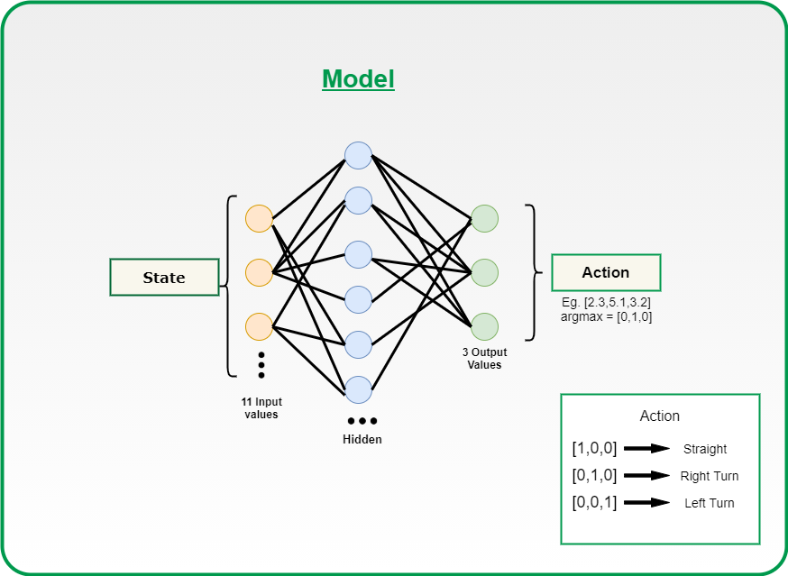

**4.Collision Detection**: Collision detection is used to check whether the snake has collided with the walls, its own body, or the bait. If a collision is detected, the game state is updated accordingly.Collision detection is the process of detecting whether two objects have collided or intersected with each other. In the context of a game, collision detection is crucial for determining if the player or game entities have collided with other objects, such as walls, enemies, or collectibles.There are various ways to implement collision detection in a game, but the most common approach is to use bounding boxes or bounding spheres. A bounding box is a rectangle or cube that encloses an object, and a bounding sphere is a circle or sphere that encloses an object. These bounding shapes are used to represent the size and position of the objects in the game world.To detect collisions, the game checks if the bounding shapes of two objects intersect. If they do, then a collision has occurred, and the appropriate action can be taken. For example, if the player's bounding box intersects with an enemy's bounding box, then the player loses a life, or if the player's bounding sphere intersects with a collectible's bounding sphere, then the player gains points. collision detection is used to detect when the snake collides with the walls or with its own body. The game checks if the snake's head intersects with any part of its body or with the wall boundaries. If a collision is detected, the game ends, and the player loses. Similarly, the game checks if the snake's head intersects with the bait object, and if so, the bait disappears, and the snake's body grows, and the player's score increases.Overall, collision detection is a critical aspect of game development, as it allows the game to respond to player actions and create a sense of interactivity and immersion in the game world.

**5.Score Keeping:** The game keeps track of the player's score based on the number of times the snake has eaten the bait.

In the snake game, the score is a way to keep track of the player's progress and success in the game. The score is updated every time the snake collides with the bait (which is not visible), and the bait disappears, and the snake's body grows.In the code, a variable called "score" is initialized to zero at the beginning of the game. Then, whenever the snake collides with the bait, the score is incremented by a certain amount, which can be defined by the programmer.

**6.Graphics and Sound:** The game uses graphics and sound to provide visual and audio feedback to the player. It includes graphics for the snake, the bait, the walls, and the score, as well as sound effects for collisions and successful bait consumption.

Overall, the architecture of the snake game implemented using Pygame in Python is modular and well-organized, with separate components for handling different aspects of the game.

The Pygame module provides various functions and tools to create 2D graphics, animations, and special effects for games and multimedia applications. It includes a range of built-in image and sound formats, and it also supports custom graphics and sounds created using external tools.In this code, the graphics are implemented using Pygame's built-in functions to draw basic shapes such as rectangles and circles on the screen. The graphics are updated and redrawn every frame to create smooth and seamless animation.

Pygame also provides functions to load and play sound effects and music. These can be used to add an immersive audio experience to the game, such as playing sound effects when the snake collides with the wall or eats the bait.

Overall, the Pygame module provides a comprehensive set of tools and functions to create both graphics and sound for games and multimedia applications, and can be used to create engaging and interactive experiences for the user.

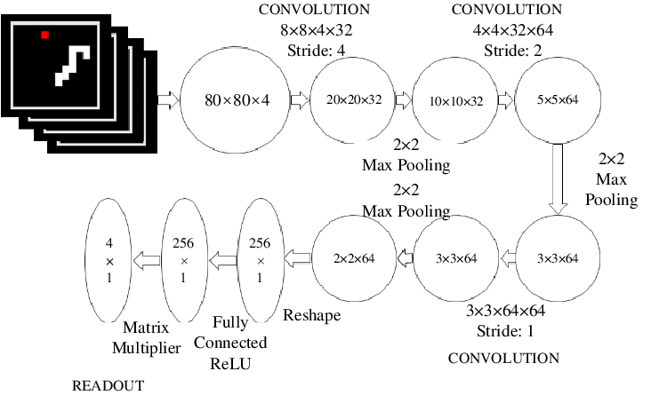

Flow of Snake Game Using Python:

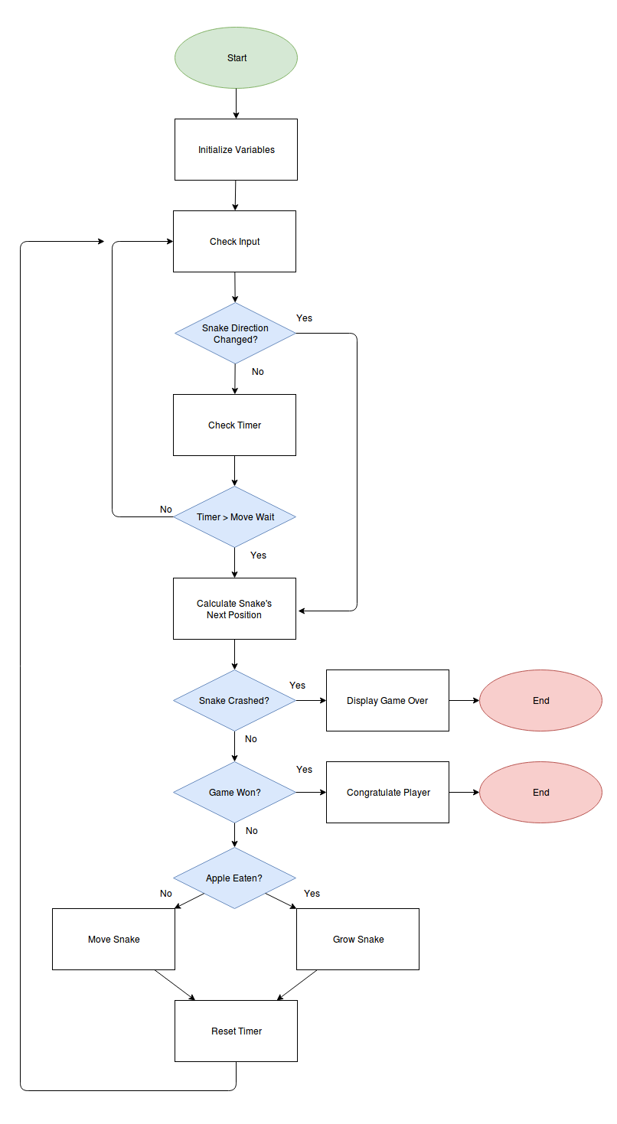

**Existing System:**

The Existing System is a simple game implemented using the Pygame module in Python. The game involves a snake that moves around the screen, and the player must prevent the snake from hitting walls or colliding with itself. The snake's movement is controlled using the right, left, down, and up keys. The snake initially moves in the right direction, and there are no objects labeled "food" on the screen. However, when the snake hits the bait, the bait disappears, and the snake's body grows. The score of the player increases for each successful collision of the snake with the food. All of these activities are implemented using functions.

**Proposed System:**

The proposed system will be a simple game implemented using the Pygame module, and it will involve a snake that moves around the screen. The player's objective will be to prevent the snake from hitting walls or colliding with itself.

The snake's movement will be controlled using the right, left, down, and up keys. The snake will initially move in the right direction, and there will be no objects labeled "food" on the screen. However, when the snake hits the bait, the bait will disappear, and the snake's body will grow.

The proposed system will keep track of the player's score, which will increase for each successful collision of the snake with the food. The game will end if the snake hits a wall or collides with itself.

To implement the proposed system, we will use the Pygame module and develop functions to handle the snake's movement, collision detection, and scorekeeping. We will also design a graphical interface for the game using Pygame's graphics capabilities.

Overall, the proposed system will be a fun and challenging game that will test the player's reflexes and strategic thinking.

**Results:**

The game involves a constantly moving snake that the player must control to prevent it from hitting walls or colliding with itself.

1.The snake can be controlled using the right, left, down, and up keys.

2.The snake starts moving in the right direction by default.

3.There are no objects labeled "food" on the screen initially.

4.Whenever the snake hits the bait, the bait disappears, and the snake's body grows.

5.The player earns a score for each successful collision of the snake with food.

All of these activities are implemented using functions.

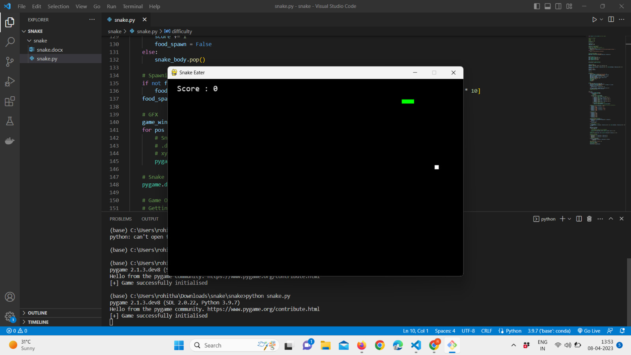

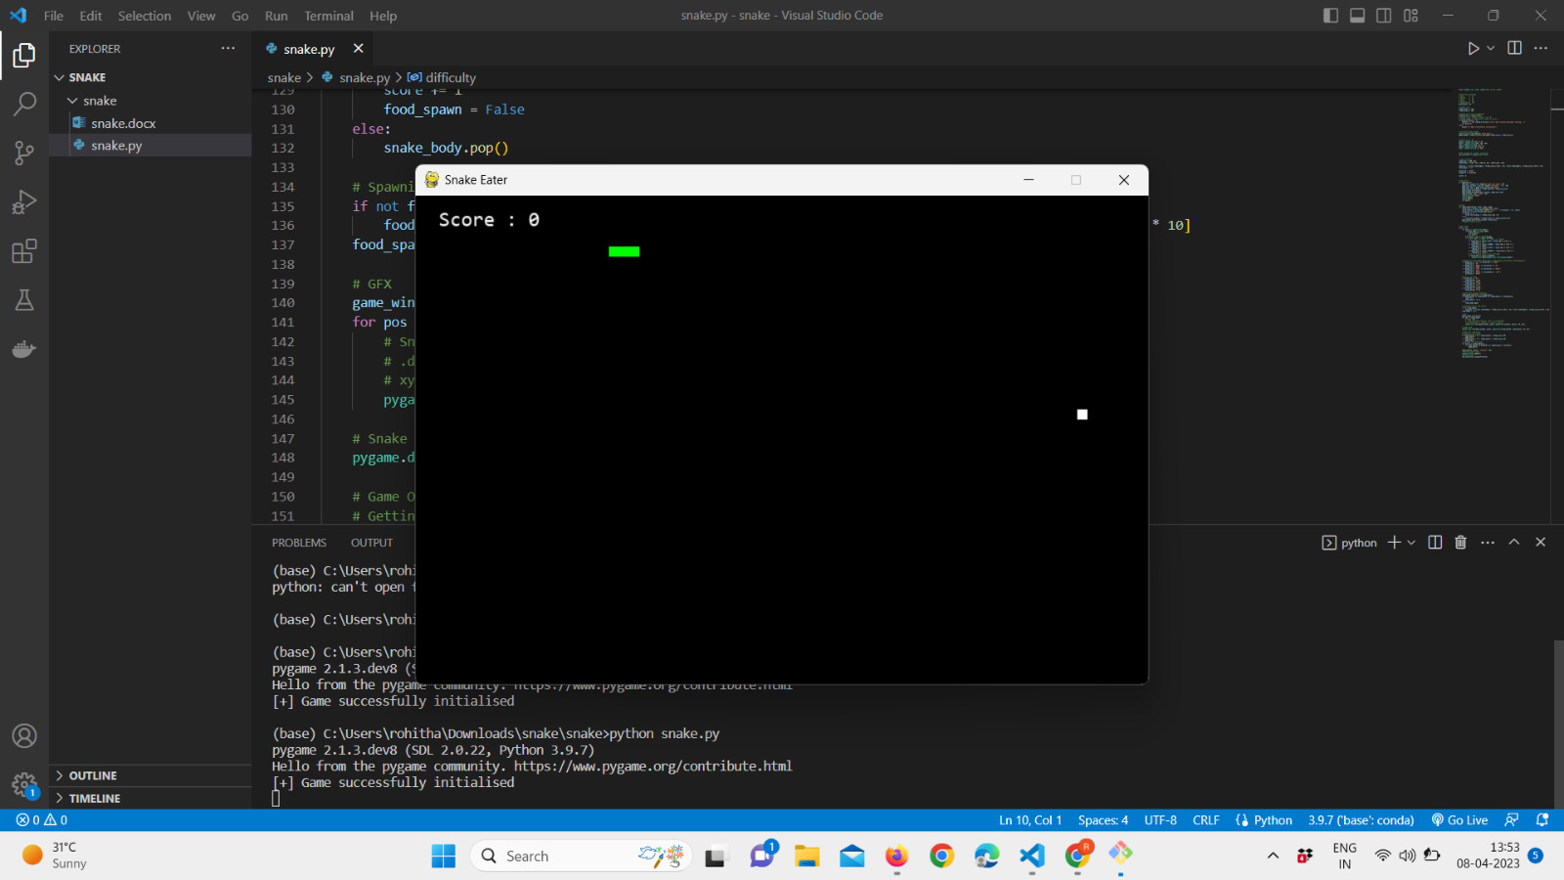

**Conclusion:**

Snake game is a popular classic arcade game that involves controlling a snake to eat food while avoiding obstacles and its own body. In this project, we aim to develop a Snake game using Python programming language. The game will utilize Python’s built-in modules such as Pygame, which is a popular module used for game development. The project will involve designing the game board, the snake, the food, and the game mechanics. The user will be able to control the snake’s movement using arrow keys, and the game will end when the snake collides with the wall or its own body. The project will also involve keeping track of the player’s score and displaying it on the screen. Overall, this project will be a fun and challenging way to practice Python programming skills while creating a classic game.

It describes the implementation of a simple game called "Snake" using the Pygame module in Python. The game involves a snake that moves around the screen, and the player must prevent the snake from hitting walls or colliding with itself. The snake's movement is controlled using the right, left, down, and up keys, and it initially moves in the right direction. There are no objects labeled "food" on the screen, but every time the snake hits the bait, the bait disappears, and the snake's body grows. The game keeps a score of each successful snake collision with food, and all of these activities are implemented using functions.

References:

1."How to Build Snake Game Using Python and Pygame," by Shashwat Jaiswal, https://www.geeksforgeeks.org/how-to-build-snake-game-using-python-and-pygame/

2."Create the Classic Snake Game with Python in One Hour," by freeCodeCamp.org, https://www.freecodecamp.org/news/create-the-classic-snake-game-with-python-in-one-hour-8fc3611cfa9/

3."Python Snake Game Tutorial for Beginners - Full Code with Pygame," by Christian Thompson, https://www.youtube.com/watch?v=CD4qAhfFuLo

4."Python Game Development Tutorial - Snake Game," by Tech With Tim, https://www.youtube.com/watch?v=QFvqStqPCRU

5."Snake Game Python Tutorial," by TokyoEdTech, https://www.youtube.com/watch?v=VLZjd_Y1gJ8

6."Creating Snake Game Using Python with Pygame," by Piyush Verma, https://towardsdatascience.com/creating-snake-game-using-python-with-pygame-8b7efc9c589

7."Build Snake Game Using Python and Pygame - Full Tutorial," by Rasika Gayan, https://www.techwithrasika.com/2021/01/28/build-snake-game-using-python-and-pygame-full-tutorial/

8."Python Snake Game - Tutorial," by Zenva Academy, https://academy.zenva.com/lesson/snake-game-python-tutorial/

9."Python Game Tutorial: Snake," by Ben Tristem, https://www.udemy.com/course/python-game-development-creating-a-snake-game-from-scratch/

10."How to Make a Simple Snake Game in Python," by Trevor Appleton, https://www.twilio.com/blog/how-to-make-a-simple-snake-game-in-python

11."How to Build Snake Game Using Pygame in Python," by Arpit Bhartiya, https://thepythonguru.com/how-to-build-snake-game-using-pygame-in-python/

12."Pygame Tutorial: Creating Snake Game in Pygame," by Code Young, https://codeyoung.blogspot.com/2019/09/pygame-tutorial-creating-snake-game-in.html

13."Build a Classic Snake Game Using Pygame and Python," by Wasiq Naeem, https://wasiqnaeem.com/build-a-classic-snake-game-using-pygame-and-python/

14."How to Build a Snake Game in Python," by Krunal Lathiya, https://appdividend.com/2021/06/03/how-to-build-a-snake-game-in-python/

15."Python Game Development Tutorial: Snake Game," by Bro Code, https://www.youtube.com/watch?v=9bBgyOkoBQ0.